**Topic: Credit Card Exploratory Data Analysis** 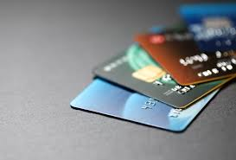

Group Members:

Bajineni Ashok Archana Kumari

Edulakanti Srinivas

**A. Dataset URL**

<https://www.kaggle.com/darpan25bajaj/credit-card-exploratory-data-analysis?select=Customer+Acqusition.csv>

**Dataset Columns Description:**

|  |  |
| --- | --- |
| **Column Name** | **Data Type** |
| **Customer** | **String** |
| **Age** | **Integer** |
| **City** | **String** |
| **Product** | **String** |
| **Limit** | **Integer** |
| **Company** | **String** |
| **Segment** | **String** |
| **Spent_Month** | **Date** |
| **Type** | **String** |
| **Amount_Spent** | **Integer** |
| **Repayment_Month** | **Date** |
| **Amount_Paid** | **Integer** |

**Objective of Study**:

The basic objective behind picking this particular Dataset is to Identify the type of customers and their spending behavior, personalize offerings based on Data as this would help bank business to market their credit cards in those customer markets based on the city. As this data would also give access to timely information to economic policymakers regarding spending, as this would help them to analyze the taxes. We wanted to see what impact the credit card would make and want to change people mindset by making them to use credit card instead of cash.

**What is a credit card?**

Before we go ahead and explain you about the dataset for our project, we have to explain what credit card is. A credit card allows its customers to purchase goods and services without using cash and pays back to credit card company at a later date. It is a small rectangular plastic card with a magnetic stripe and a signature panel as they have unique account mentioned on the card to identify the person while using it, company would keep a check on his/her account how much of credit has been used out of credit granted to bill him back the amount. If the customer is paying back the amount before the due date, he will not be charged with interest or else the credit card company would charge him interest as a penalty.

**Information about the Dataset:**

The dataset has three csv files, first .csv file refers to **customer acquisition** this includes the details of the customer before issuing the card like Customer Age, Type of Card, limit and their Occupation.

Before Granting the credit card the Credit Card Company would request for details like age, income, profession based on the details provided they would make an assessment about credit card limit, card type and even customer would like to know details about annual fee charged on credit card, Interest percentage, minimum num of days given to repay as these details would bind both parties in the future. They would take details about a customer if he/she is self-employed ,Govt employee or a Private employee because as per details they would assess the risk if he is a Govt employee the risk would be less if he is a private employee then the risk is medium and if he is a self-employee then the risk would be higher as the income source is not definite usually for these customers and they don’t want to take risk by giving more credit to these self-employed customers.

The second csv files contain details of **Repayment** by particular customer for respective month as this would help us analyze which customer has defaulted for particular month and have columns like customer, month and amount.

As a credit card company they wanted to keep track off every payment made by the customer and also missed payments from the customer so they will take necessary step to stop further credit facility to that customer and levy charges for late payment and if the customers still not paying heed in spite of reminders then the company would go ahead to block the credit card and issue legal notice. Even the customer will keep checking the payments missed so that he will have an idea about any extra charges levied upon him and will ask the credit card company to remove any extra charges on his account.

The Third csv file has details of customer **Spend** on different activity liking purchasing goodsor services and have columns customer, month, type and amount.

Credit card statements show exactly how much money you have spent in a particular month on particular item and its necessary thing to get reimbursement or tax deduction on the amount spent. A statement will act as a backup document for business related purchases although you still want to hand on to receipt for purchases that plan to deduct or get reimbursed .Customers will also get credit card transaction alerts if you agree with the company as these alerts will help you detect fraud quickly but they help track the spending. One more way to keep track of spending is to request for balance by simply sending a text message.

**B. Data Visualizations**

1. We want to analyze which Age group is applying for credit card and which age group is having high Credit Card Limits

In order to analyze which age group has high credit card limit we have selected two attributes one is age and the other one is Avg Limit in the below tableau screenshot. The highest average credit card limit for the age of 75 is highest among all the age groups and the lowest being for the age group of 55. We have used **Rank** to show the highest to lowest limit for each group.

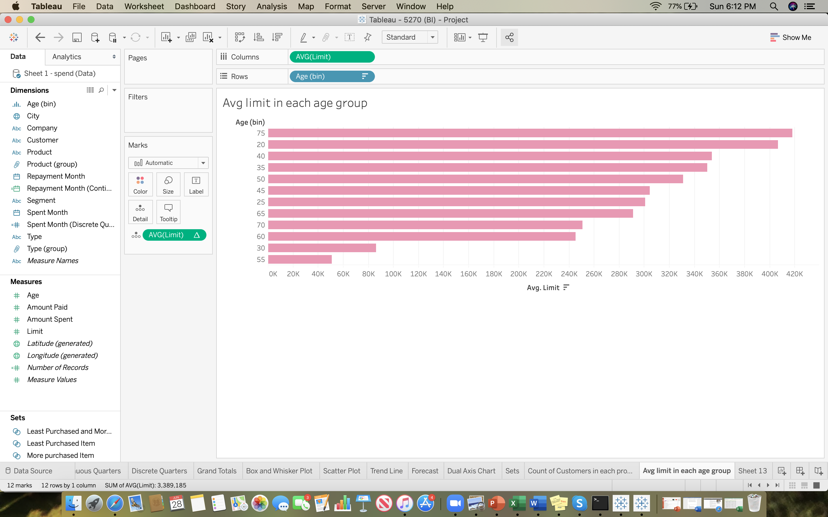

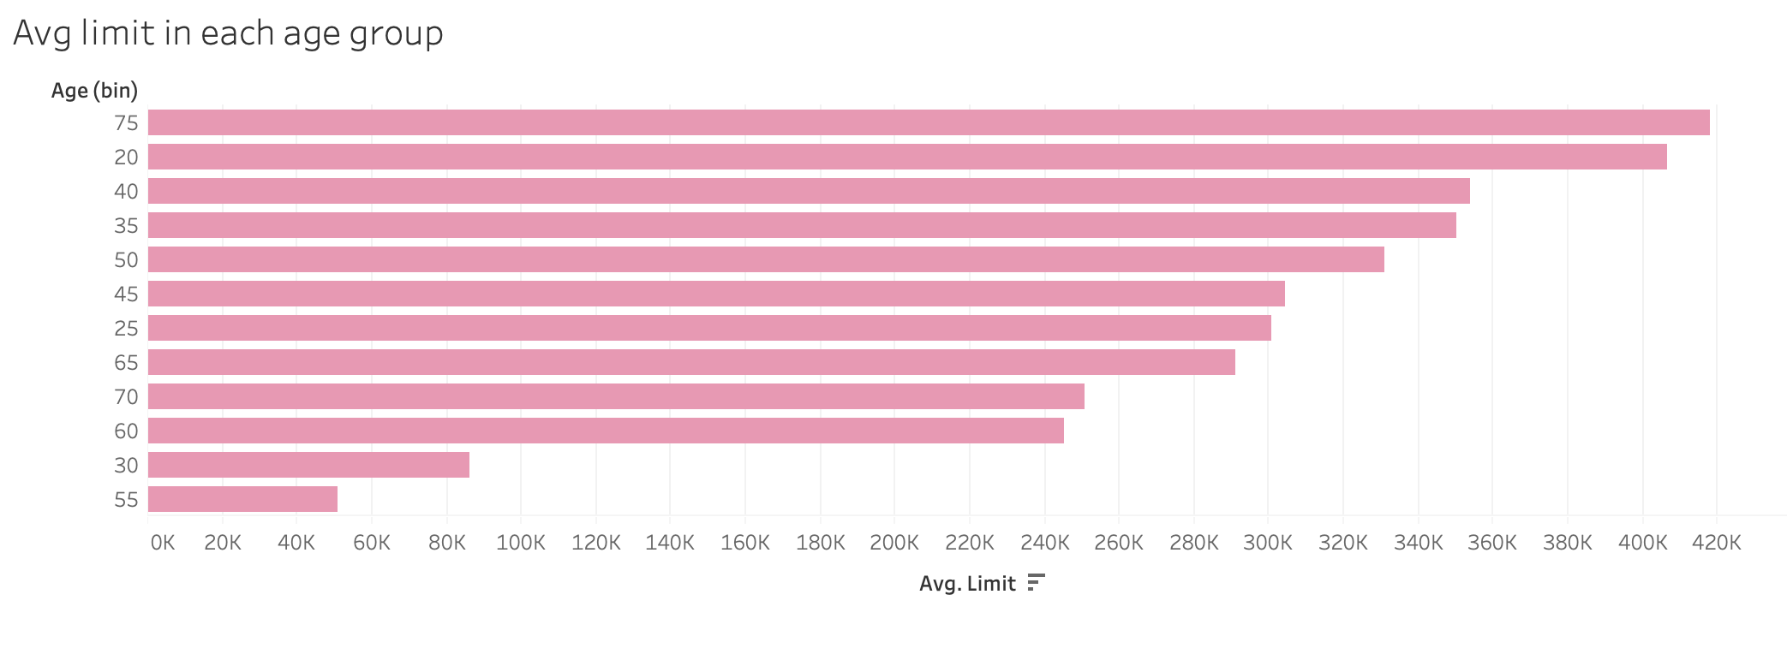

**Rank Chart in Visual 1**

1. Compare which Product type has highest number of customers

From the below screenshot we can see there are three types of products offered by credit card company those are Platinum, Gold and silver and every card type has its own customers based on their requirement. If we could look at the below tableau screen we have taken two important attributes to know the count of customers for **Silver card type** there are 56 customers in the age group of 50 and lowest in this product type is there is one customer with the age 55 who applied to this product type.

Platinum card product type -For this Platinum card type there are 95 number of customers for the age group of 35 being the highest and lowest being 18 customers in the age group of 20

Gold card product type -In this product type the highest number being 181 credit card holders in the age group of 25 and the lowest numbers a single customer each in the age group of 30 and 55. we used **Histogram** to plot and created a bin for age.

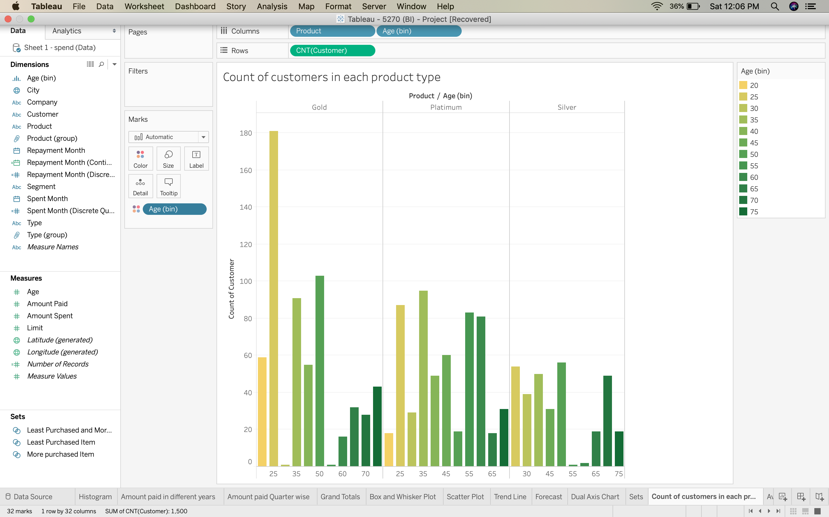

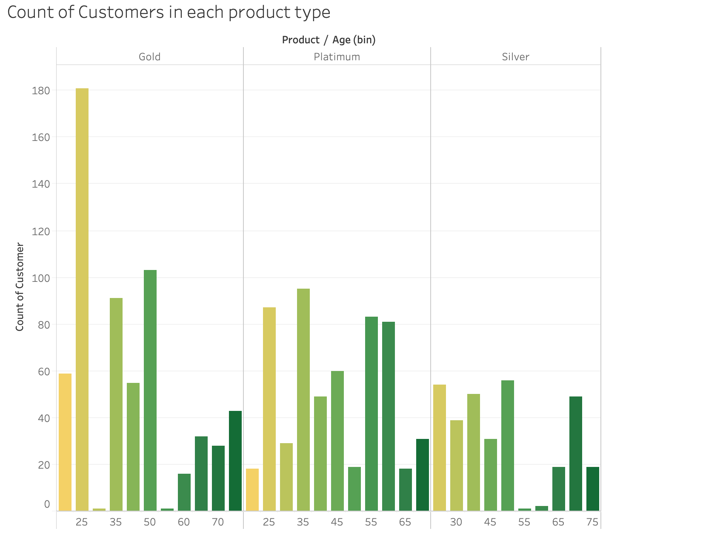

**Histogram Chart in Visual 2**

1. Find out which segment has highest number of credit cards

We have taken two attributes to find which segment has highest number of credit cards and there are 5 segment types Govt, Normal salary, Salaried_MNC, Salaried Pvt and self-employed. The highest number of credit card holders are Normal salary people as count being 441 people and lowest credit card holders being Salaried_MNC. This shows people who has normal salary has highest requirement for credit cards and there is a possibility that this segment type has highest approval rate among other segment types.

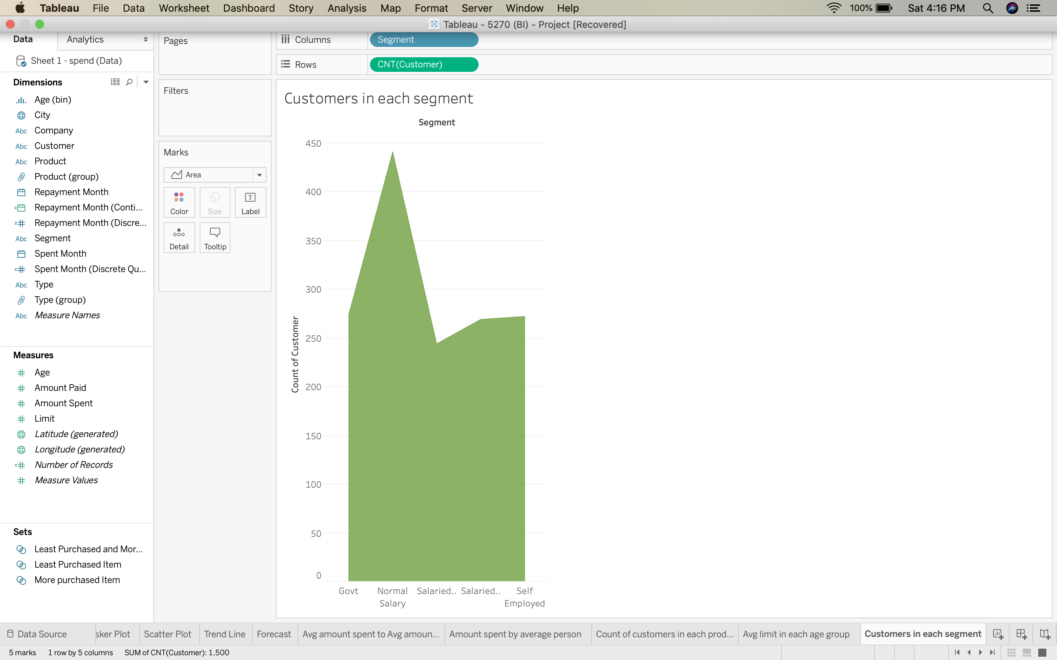

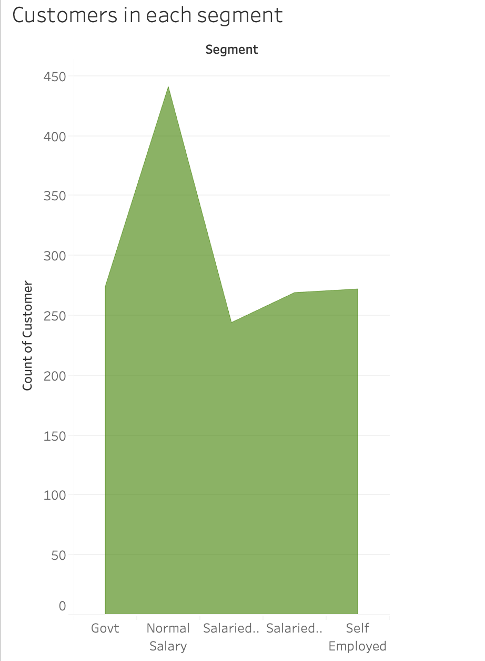

**Area Chart in Visual 3**

Amount spent by the different age group and the type of products or services purchased.

We have identified three attributes to answer the above question is Avg age, Type and Amount spent and we have used **sets** to combine the information to identify more purchased to least purchased items. The money spent on petrol being highest among all the products and services on which people have spent maximum and the least amount spent being the sandals and to determine this we have used scatter plots

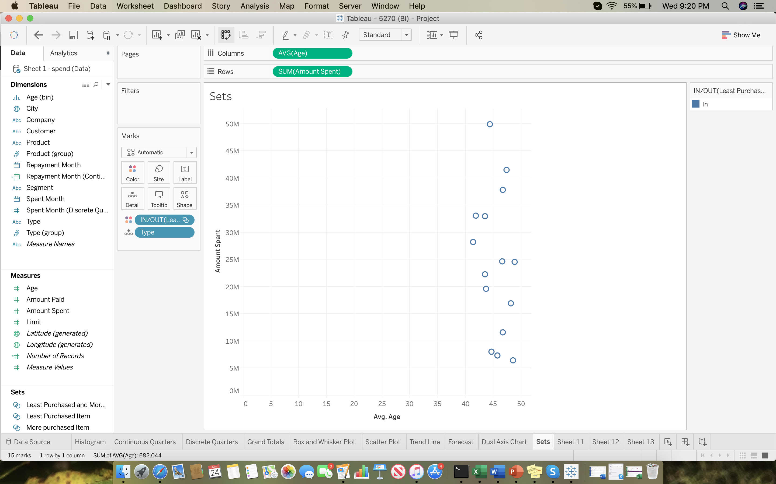

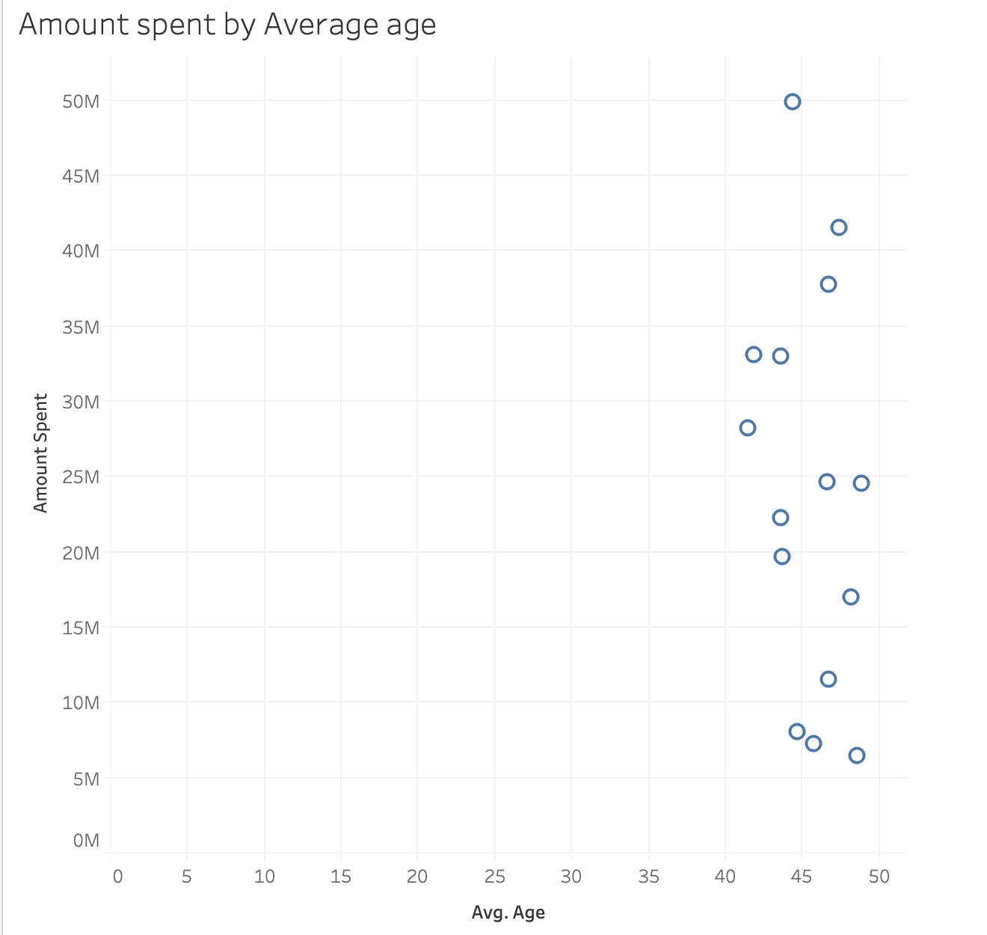

**Sets and Scatter Plot in Visual 4**

1. Comparison of Avg amount spent to Avg Amount paid during the 3 years

For this Analysis we used three attributes Repayment year, Avg amount paid and Average amount spent for the years 2004,2005 and 2006. In order to see what avg amount has spent and Avg amount paid we used **Dual Axis chart** which shows the comparison

For the year 2004 Avg amount spent on various products and services is 217,436 and Avg amount paid in the year is 288,085 as this might also includes the amount of previous years as well.

In the year 2005 Avg amount spent on the products and services is 234,233 and the Avg amount paid is 242,928.

In year 2006 Avg amount spent on the products and services is 257,134 and the Avg amount paid is 294,757

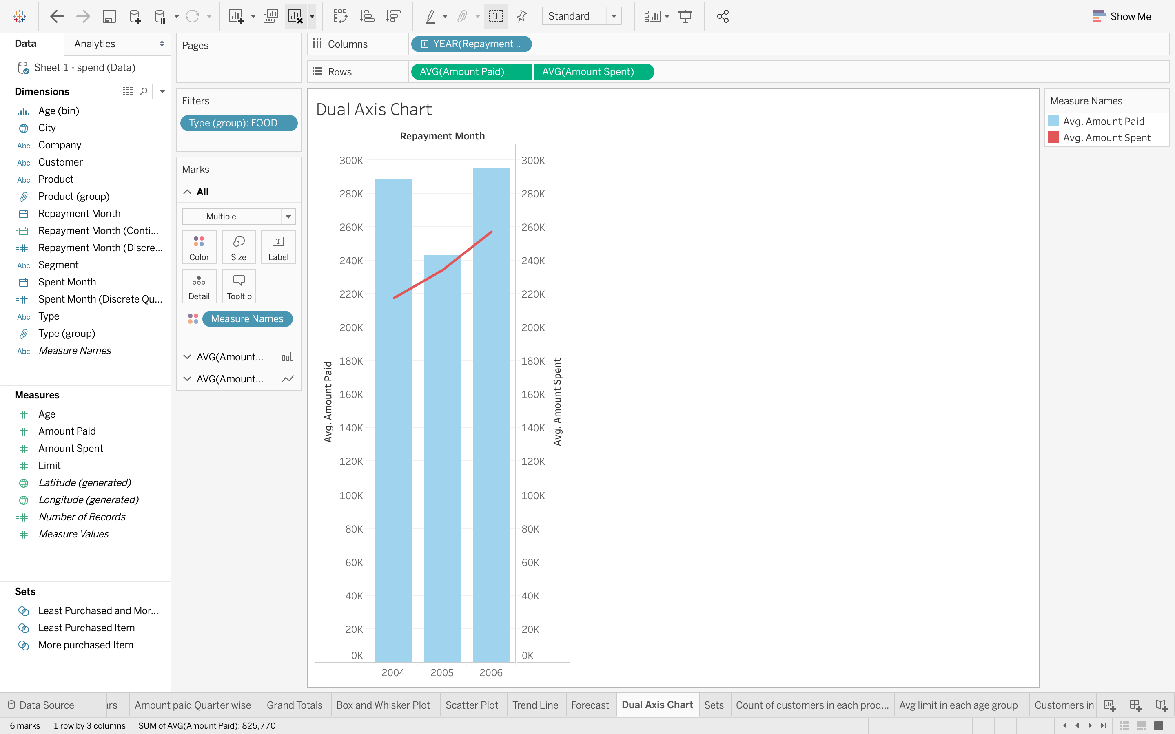

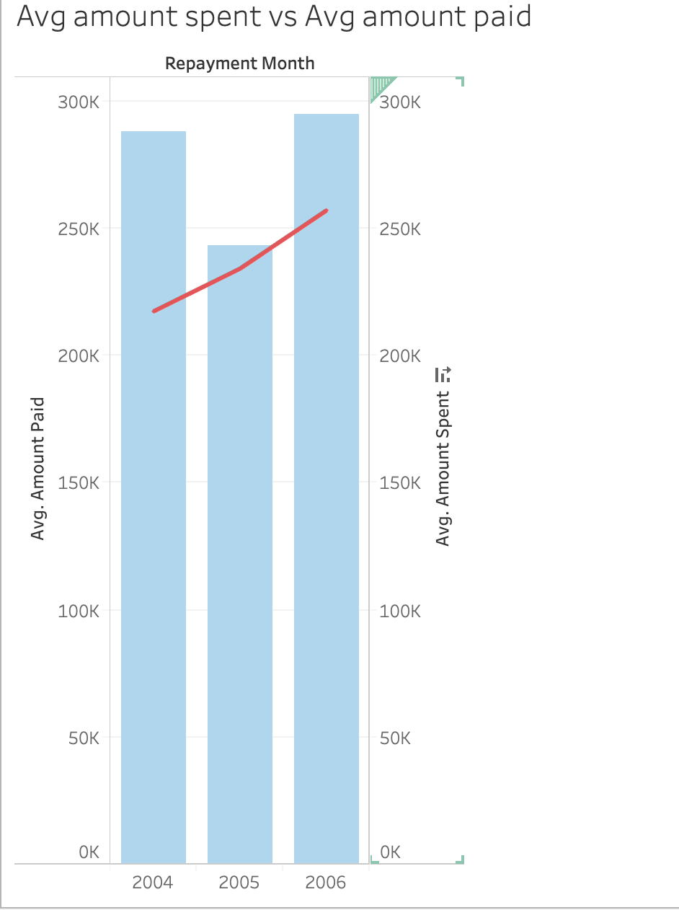

**Dual Axis in Visual 5**

1. Predict repayment for the year 2007 based on previous years?

This is the important aspect for every management to know how the business would perform in the next year based on the previous performance and based on the analysis they would plan a strategy to achieve the target may be similar to the one predicted or may be much higher .So, in-order to forecast the repayment for the year 2007 we have the used the feature called forecast and used 3 important attributes year of repayment and month on the columns section which are basically dimensions and used amount paid from the measures section on to rows . If you closely observe the below screenshot it shows us the highest amount paid for the year 2004 is 33,730,003 and the lowest being paid for that particular year 2004 is 3,151,452 and based on this amount it calculates the average amount limit in that year. Let us now take a look for the year 2005 the highest amount paid for that year in the month of May is 79,447,758 and the lowest being in the month of Jan and the amount paid is 281,066 and the average amount for the year 2005 is 14,707,794.Now we are looking at the figures for the last year 2006 and the highest being 42,617,473 for the month of May and the lowest is for the month of July . The system estimated the amount would be paid in the 2007 approx. 14,00,000 for this we have added filter on product

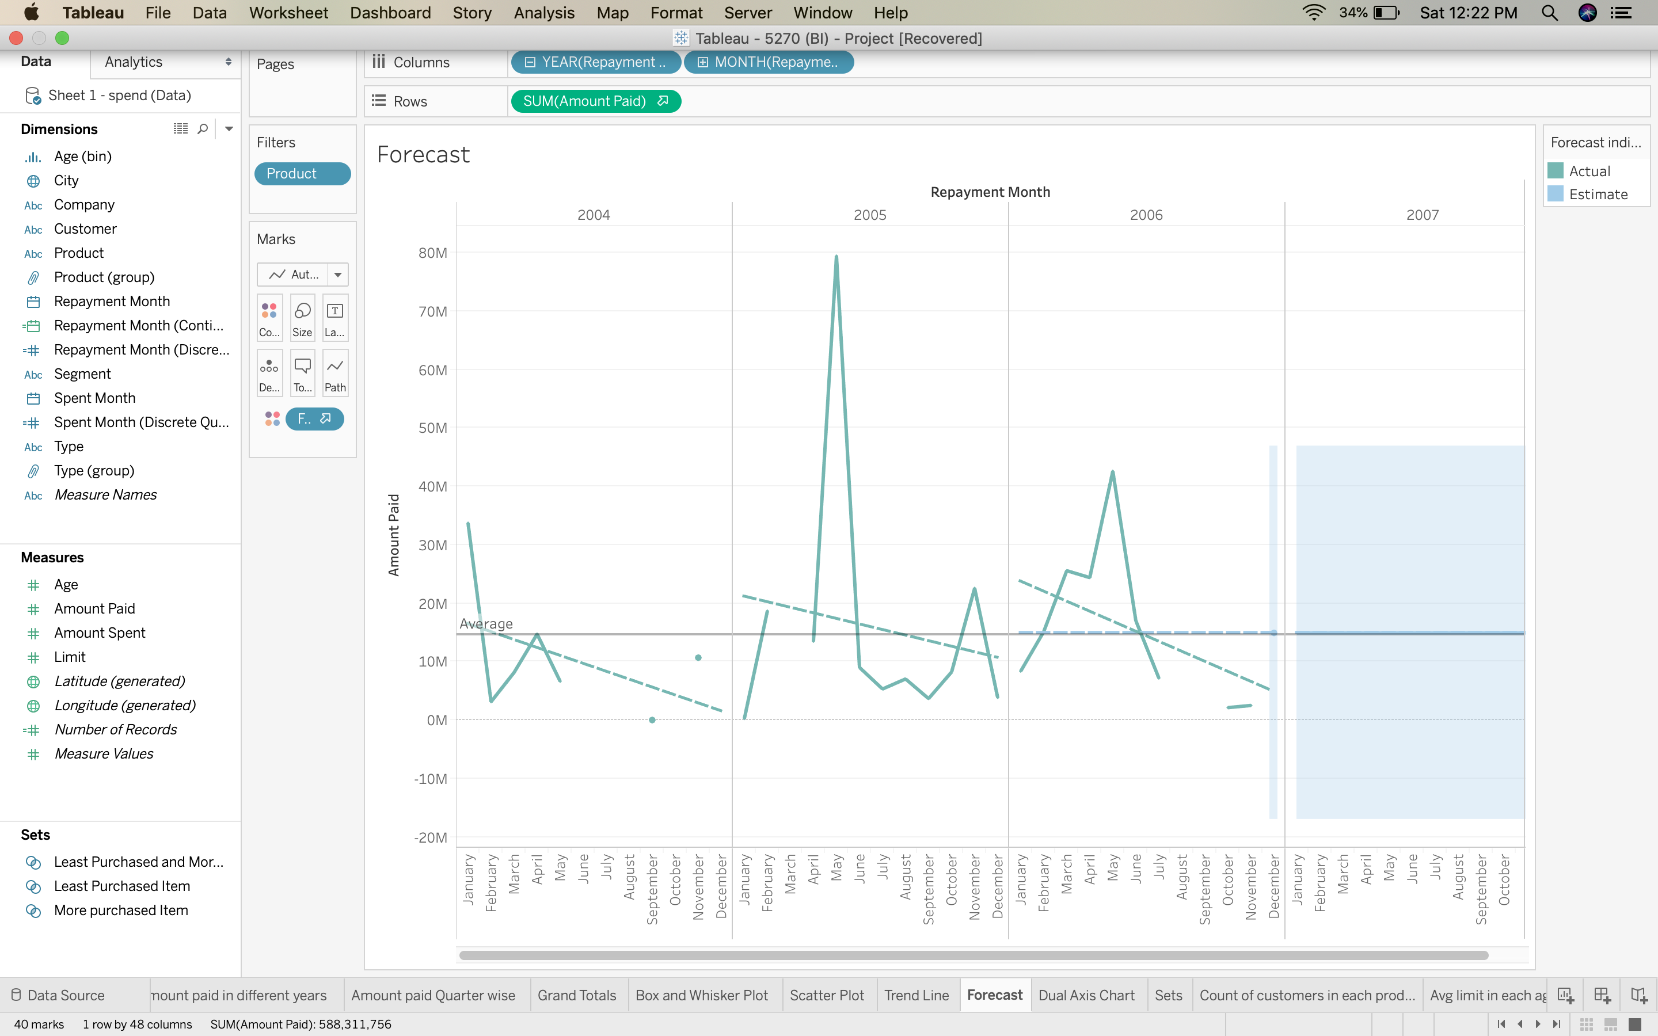

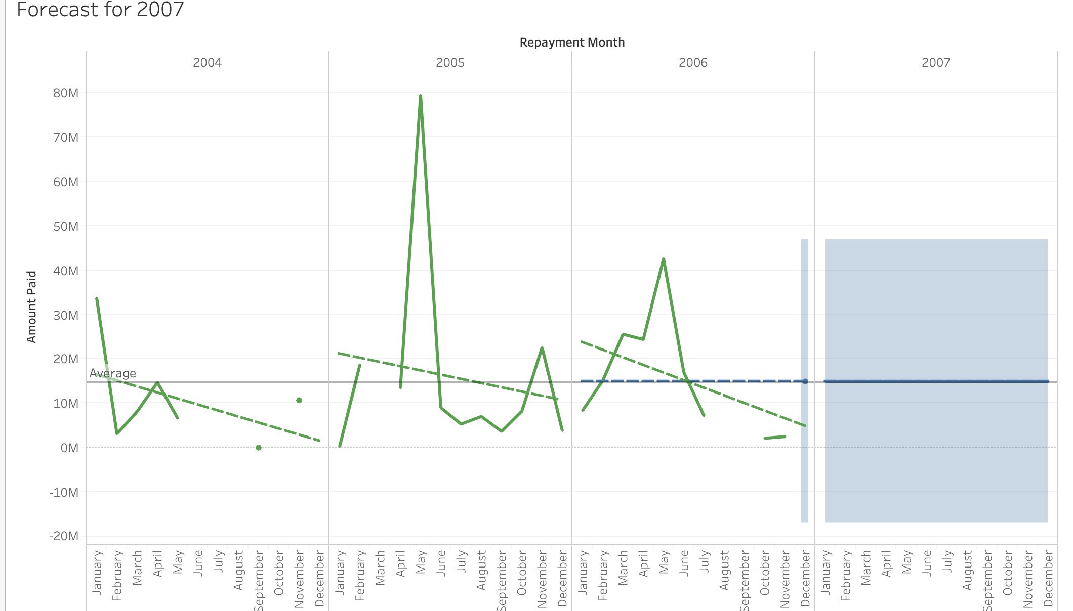

**Forecasting and Reference Line in Visual 6**

1. Find out the trend line for the product type, limit and age in particular city

We have used few attributes like product, age, city and limit to see the pattern. product and age have been used in the columns and city; limit has used in the rows to see how the limit has been assigned to different product type as per their age. The highest credit limit is 5,00,000. Generally, trend is used to predict the continuation of a certain trend of a variable. Tableau takes the dimensions and measures field to create a trend line. There are 8 cities which has all the three product types, limit, age etc.

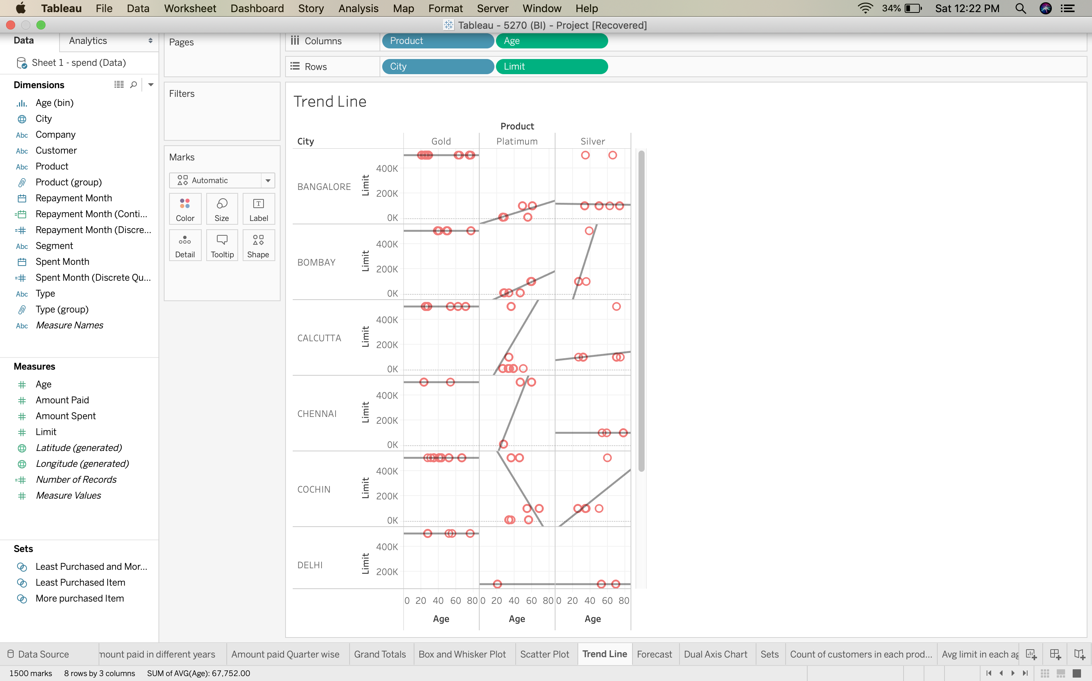

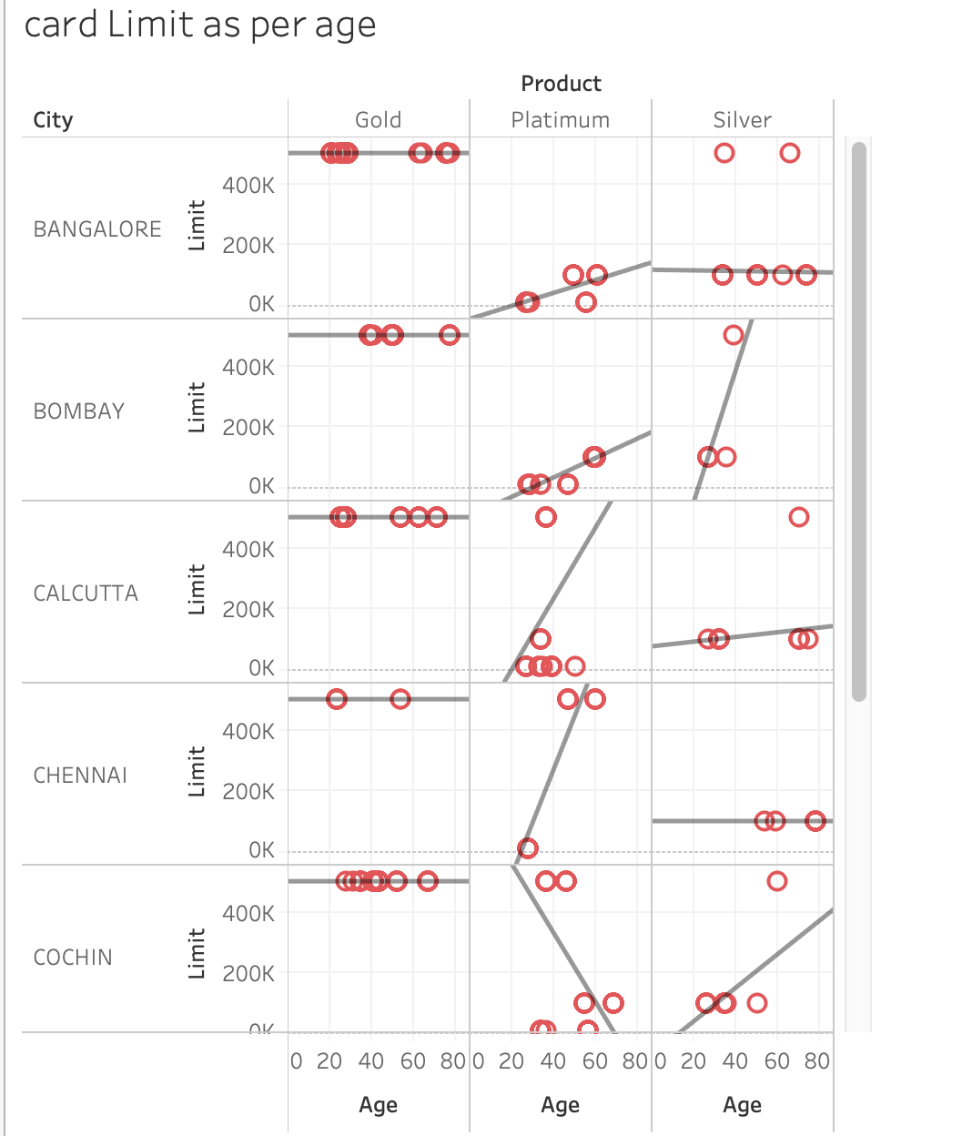

**Trend Line in Visual 7**

1. Identify amount paid in different years quarter wise

This is an important for the both the credit card company and the economic policymakers to see how much money is paid by the customers to see on a higher level how much money has been recovered. The credit card companies cannot lie about taxes to tax authorities and it also keeps an eye to recover money from its customers as early as possible.

For the below visualization two fields has been used repayment month and amount paid we used **continuous series** quarters and the quarters has been divided in to 4 quarters for three continuous years.

Basically, to see which quarter has highest and lowest performance in terms of amount paid

In 2004 quarter1 has the highest amount paid by the customers Rs 45,050,793 and quarter 3 has seen lowest with 31,836.

In 2005 quarter 2 has been highest in terms of amount paid as it stood at Rs101,986,577 and lowest in the quarter 3

In 2006 quarter 2 has been highest at Rs 84,049,944 and lowest in quarter 4 with Rs 5,101,272.

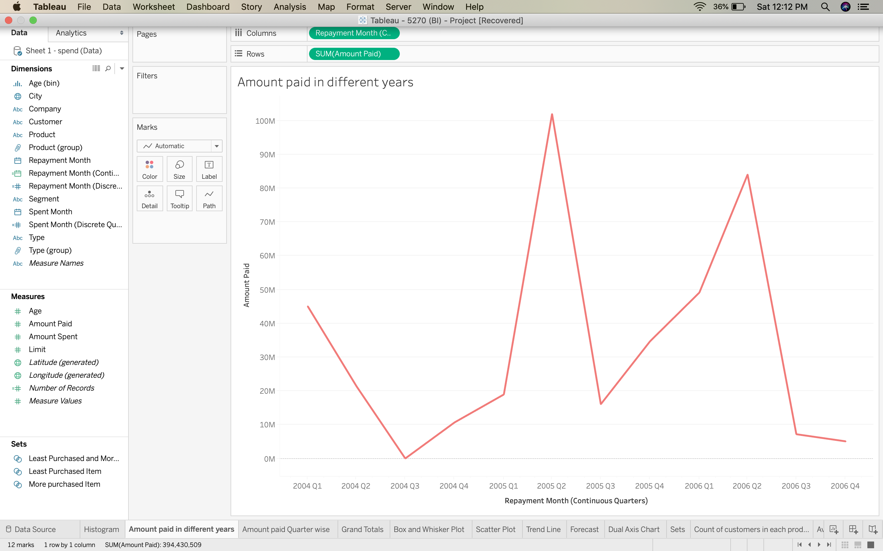

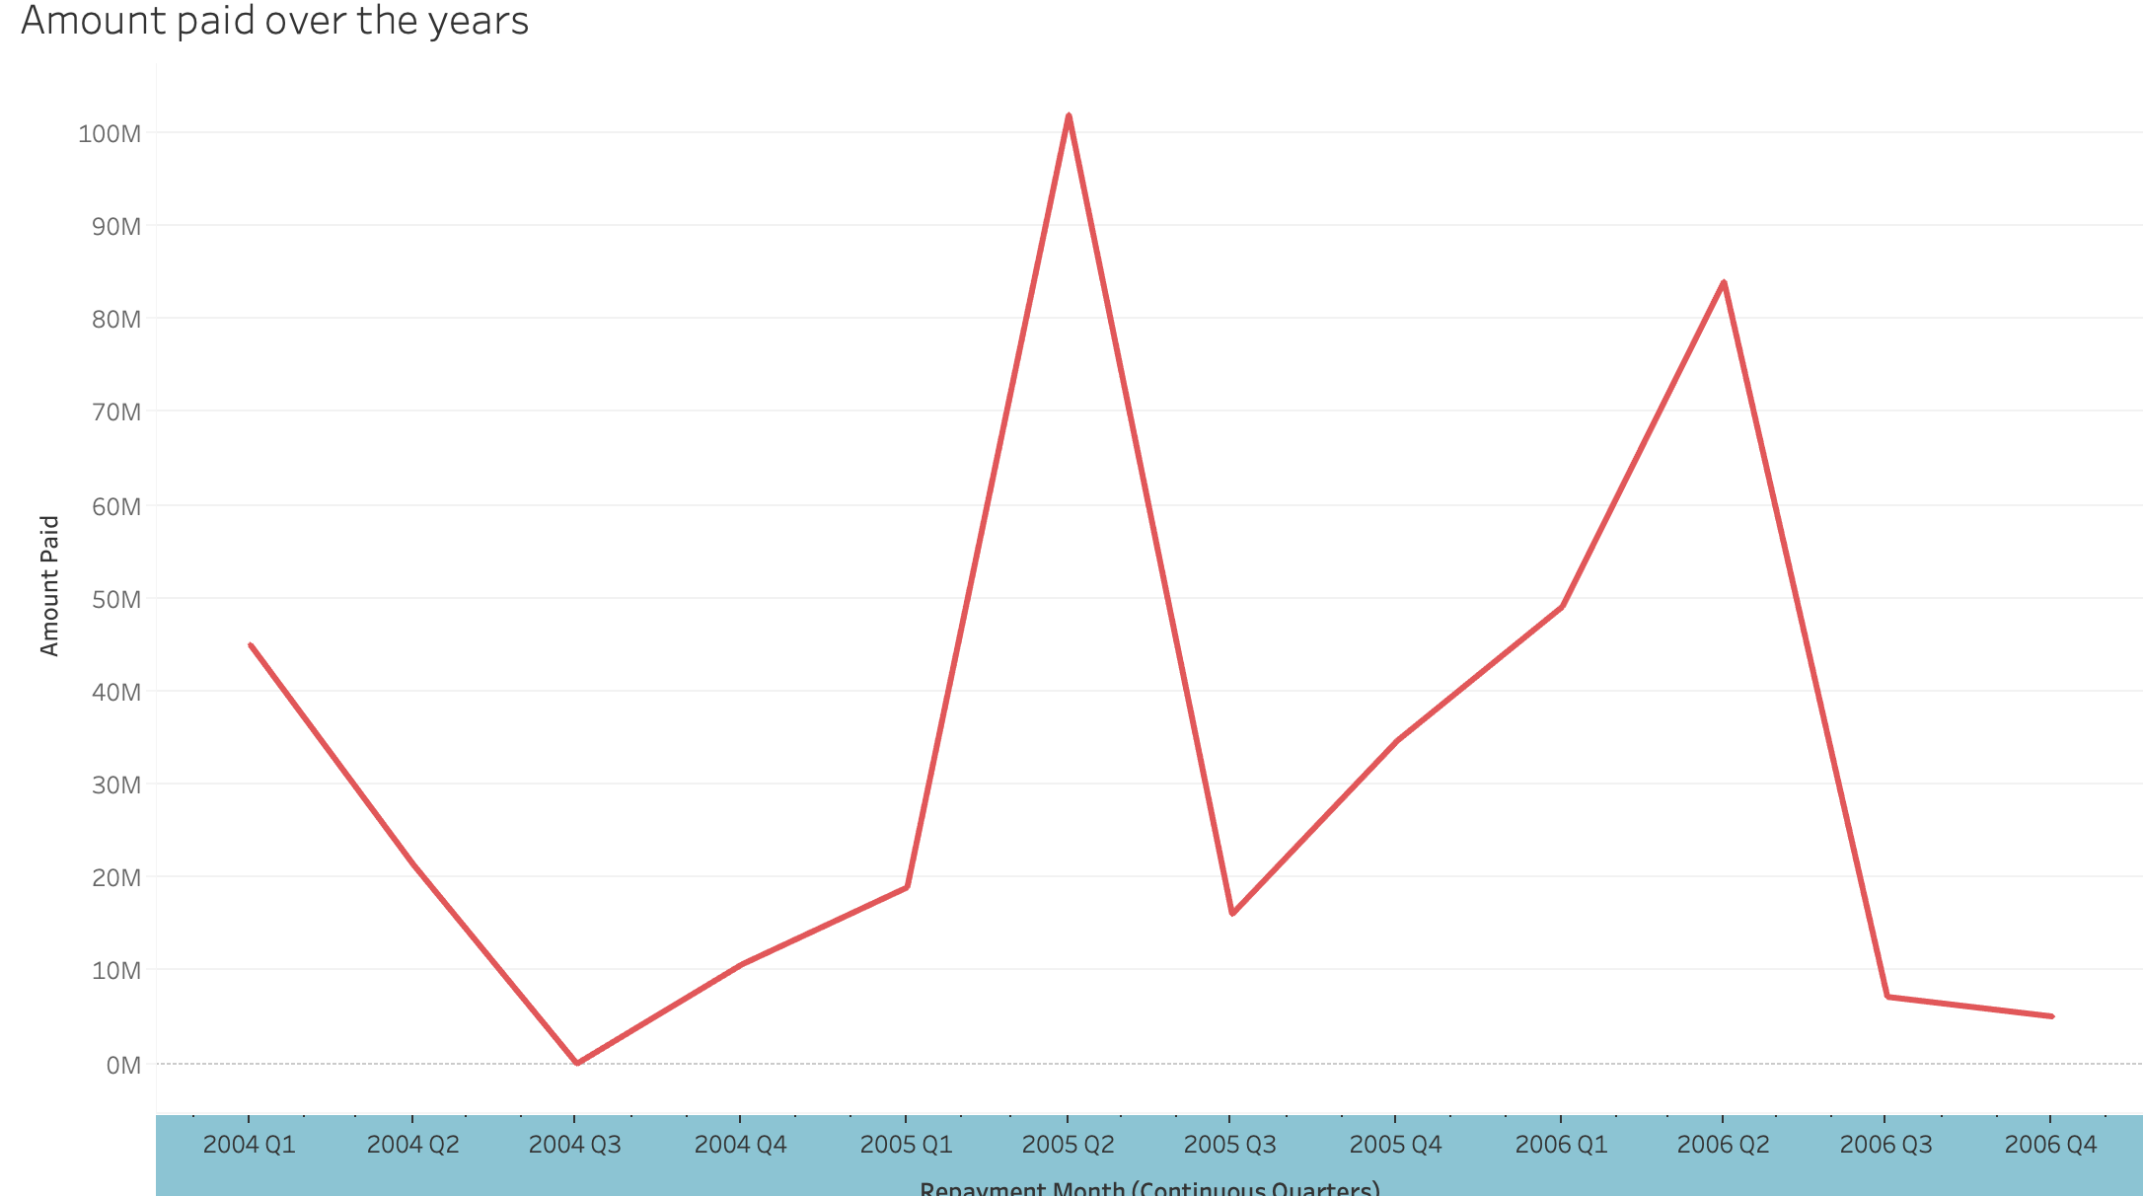

**Dates in Visual 8**

In the below screenshot we showed how much credit company has received through quarters by using **discrete series** using the bar chart. The highest amount of money paid in second quarter is high and lowest in quarter 3.

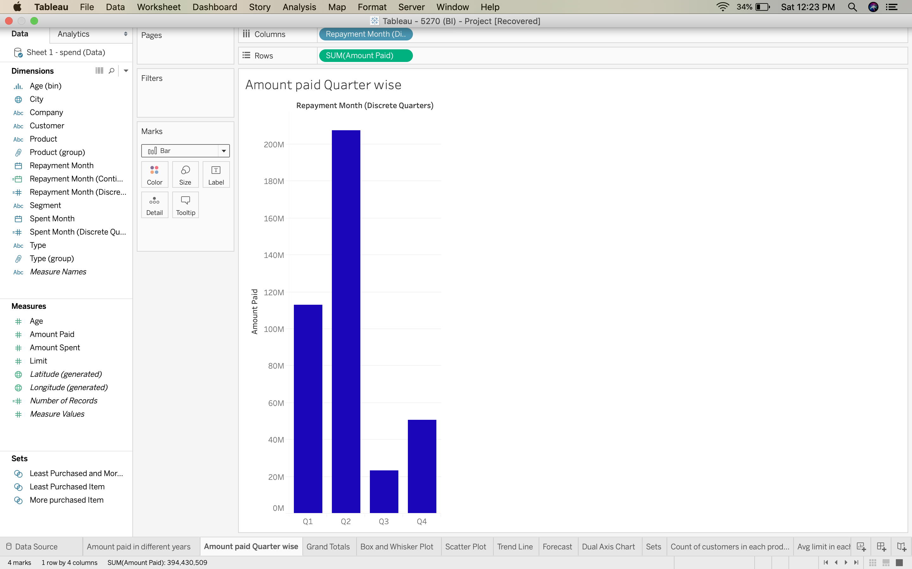

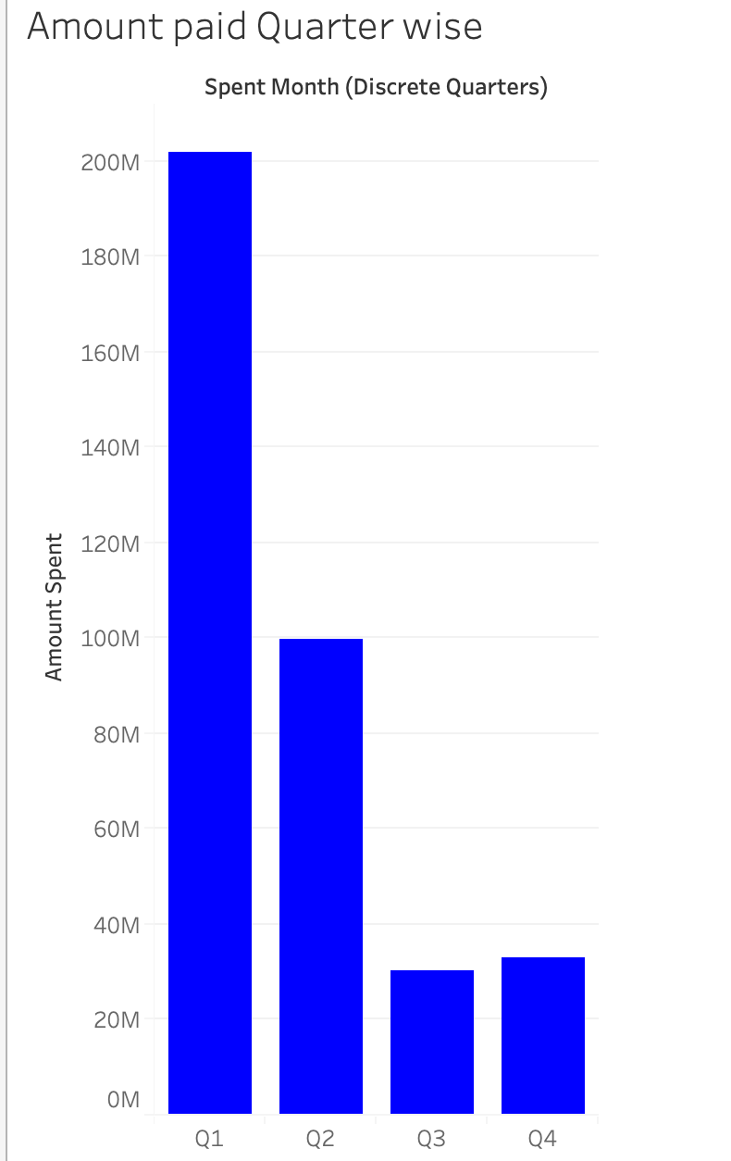

**Dates in Visual 9**

1. Ascertain total limit for any product type in the year spent

We want to find total limit for gold product type with amount spent for that we have used 4 different attributes product, year of amount spent, Amount spent and the limit and plotted them on **box and whisker plot**. In the year 2004 for the city of cochin, gold product type we could see total limit was Rs 17,000,000 and the amount spent was 7,315,850 which is well within the sanctioned amount. Similarly, if we observe in the year 2005 for city Bangalore the total limit is 29,000,000 and the total amount spent is Rs 12,892,363 after the careful observation comparing the amount spent with limit we see that amount spent is always within range.

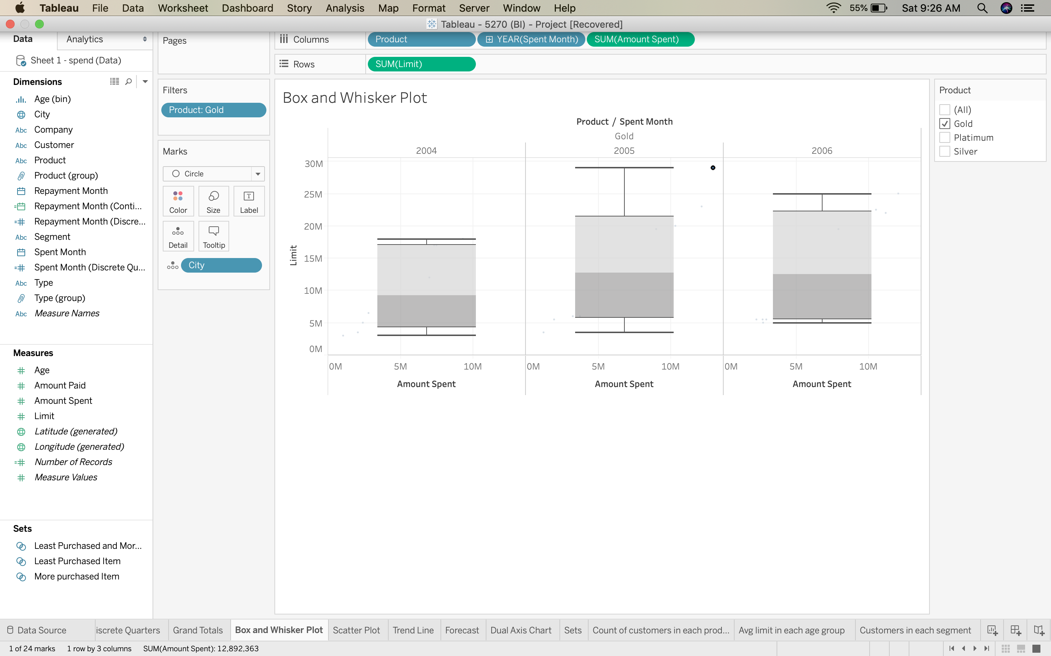

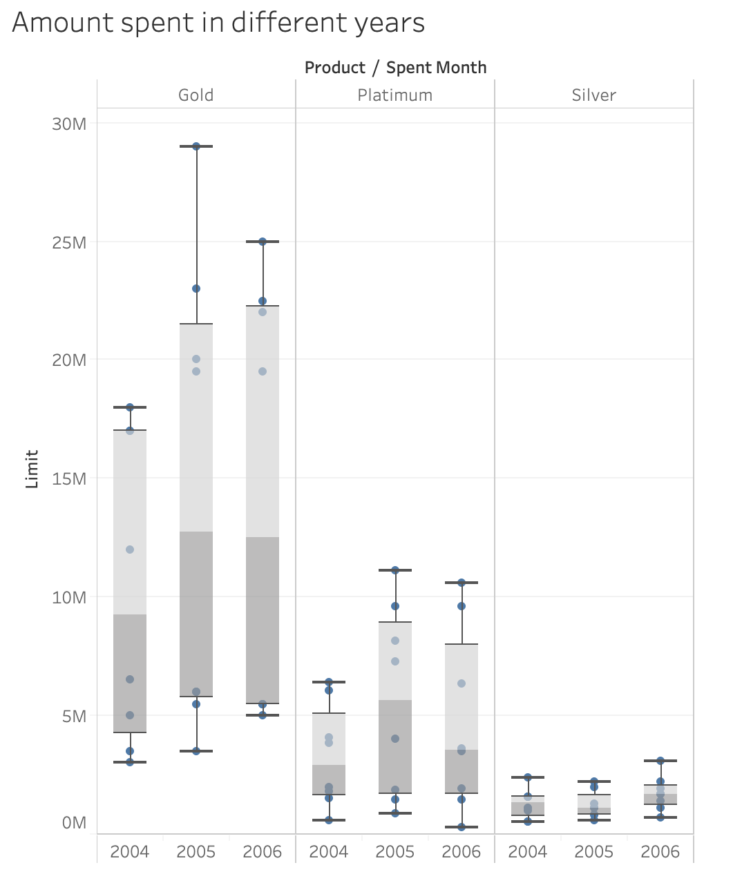

**Box and Whisker Plot in Visual 10**

**C. Dashboard**

A Dashboard is a collection of several graphs at a single place, it lets you compare variety of data in a single place rather than going on to several worksheets. Worksheets and Dashboards are interconnected because if you modify anything in the worksheet it also gets reflected on Dashboard. From the below Dashboard we can compare four different things together in the first chart we can analyze the Average limit granted to particular age group as it clearly shows Avg limit to the age group of 75 has highest among all and for Avg limit to 55 years has been lowest and they are currently ranked as per their limit.

In the second graphical representation the credit card has been granted to several people based on their jobs, so we wanted to see for which different segments of people has highest number of card holders. There are several segments like Govt salaried people, Normal salary people, Normal salary people of MNC, Salaried private and self-employed among these segments high credit cards being granted to normal salary people there are 441 customers and the salaried mnc customers are lowest as they stand at 244 customers

In the third chart comparison has been made between Avg amount spent to Avg amount paid in the year 2005 the difference between avg amount paid to average amount spent has been lowest and performed very well compared to the other two years and the year 2004 has the highest different between avg spent to avg amount paid.

Last visualization is very useful for a company and policy makers because by looking at the visualization it is clear that customers spent money on different products and services so what we did to get the clear picture we have segregated segment type and different states. When we speak about Bangalore govt segment type customers spent largely on buying train tickets and amount spent on movie tickets is less

In Bombay for this Govt segment type most of them spent money on Clothes and less on rental

In Calcutta most of them spent money on petrol and less money on car service

In Chennai city most of them spent money on petrol and less amount of money spent on travel using auto

In Cochin most them swiped credit card to buy camera and less on movie tickets

In Delhi Govt segment type has spent their money most in travelling in Auto

In Patna majority of the amount spent on buying cameras

In Trivandrum as well they spent money on buying cameras followed by buying petrol.

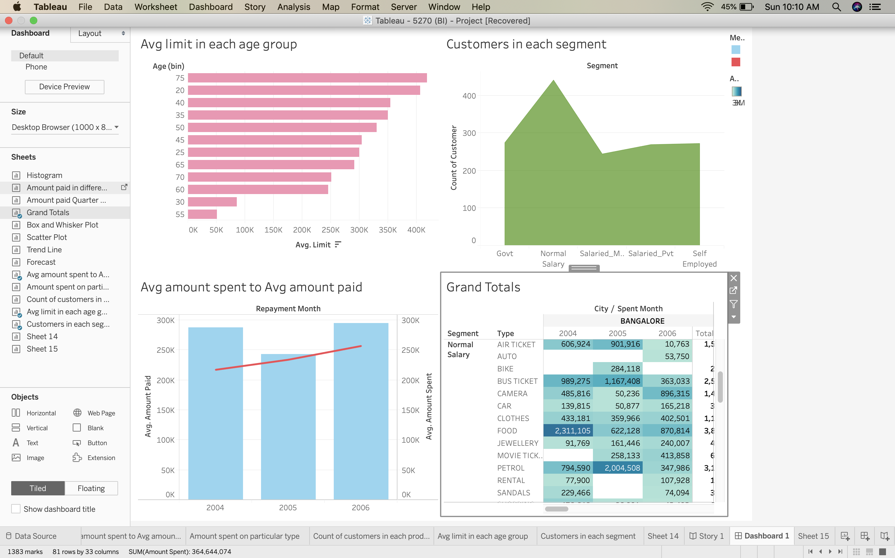

**D. Story Telling**

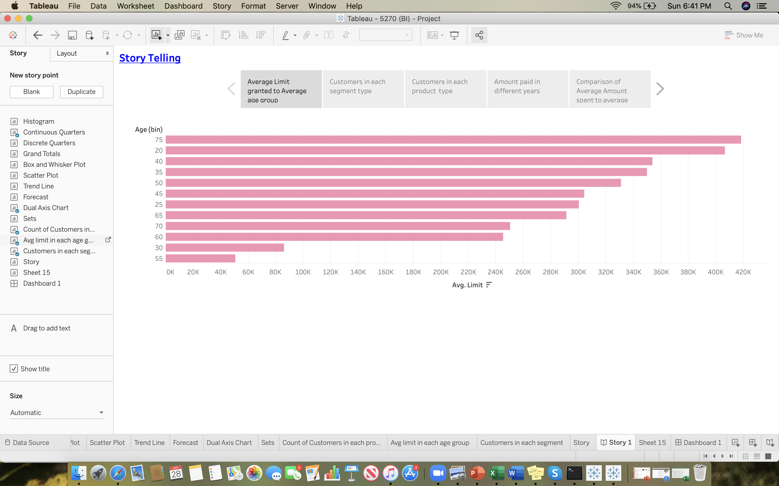

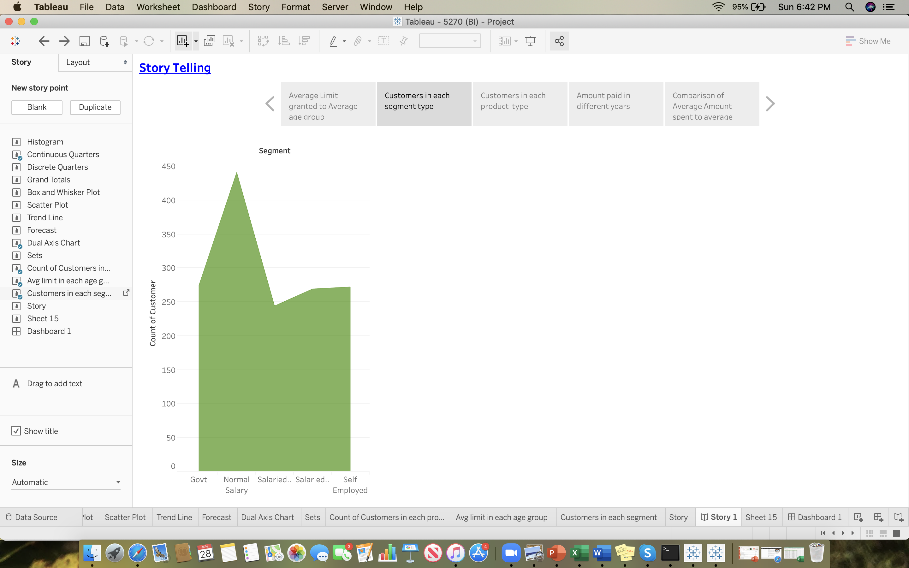

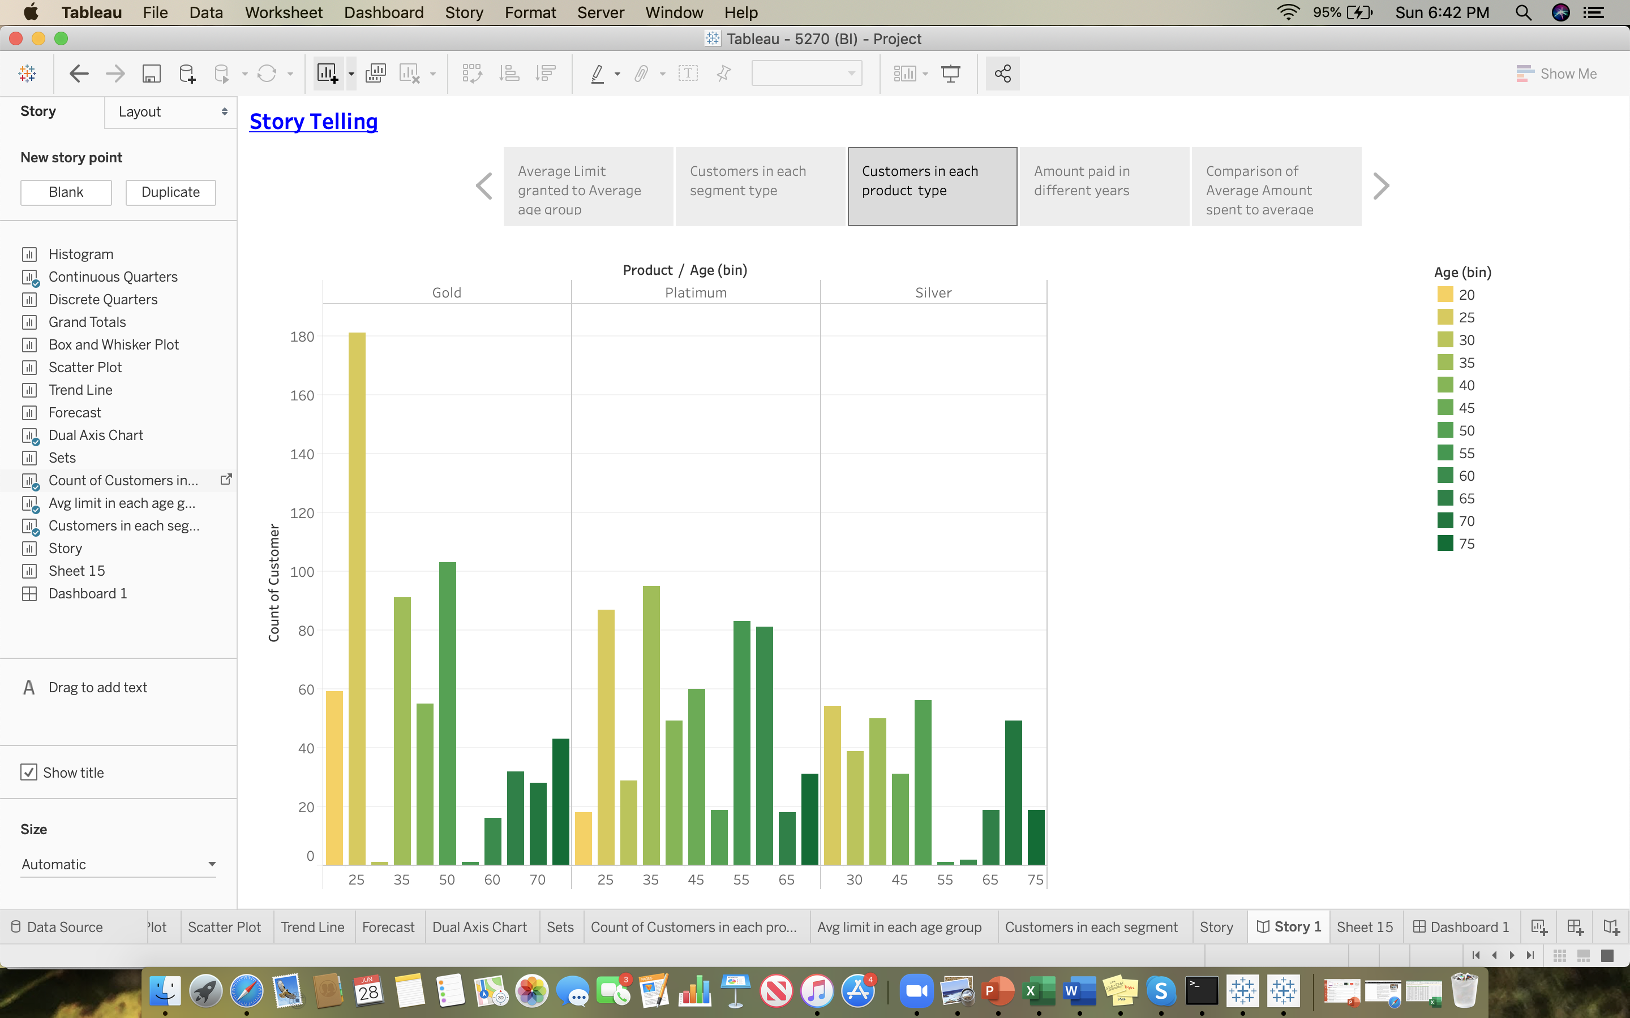

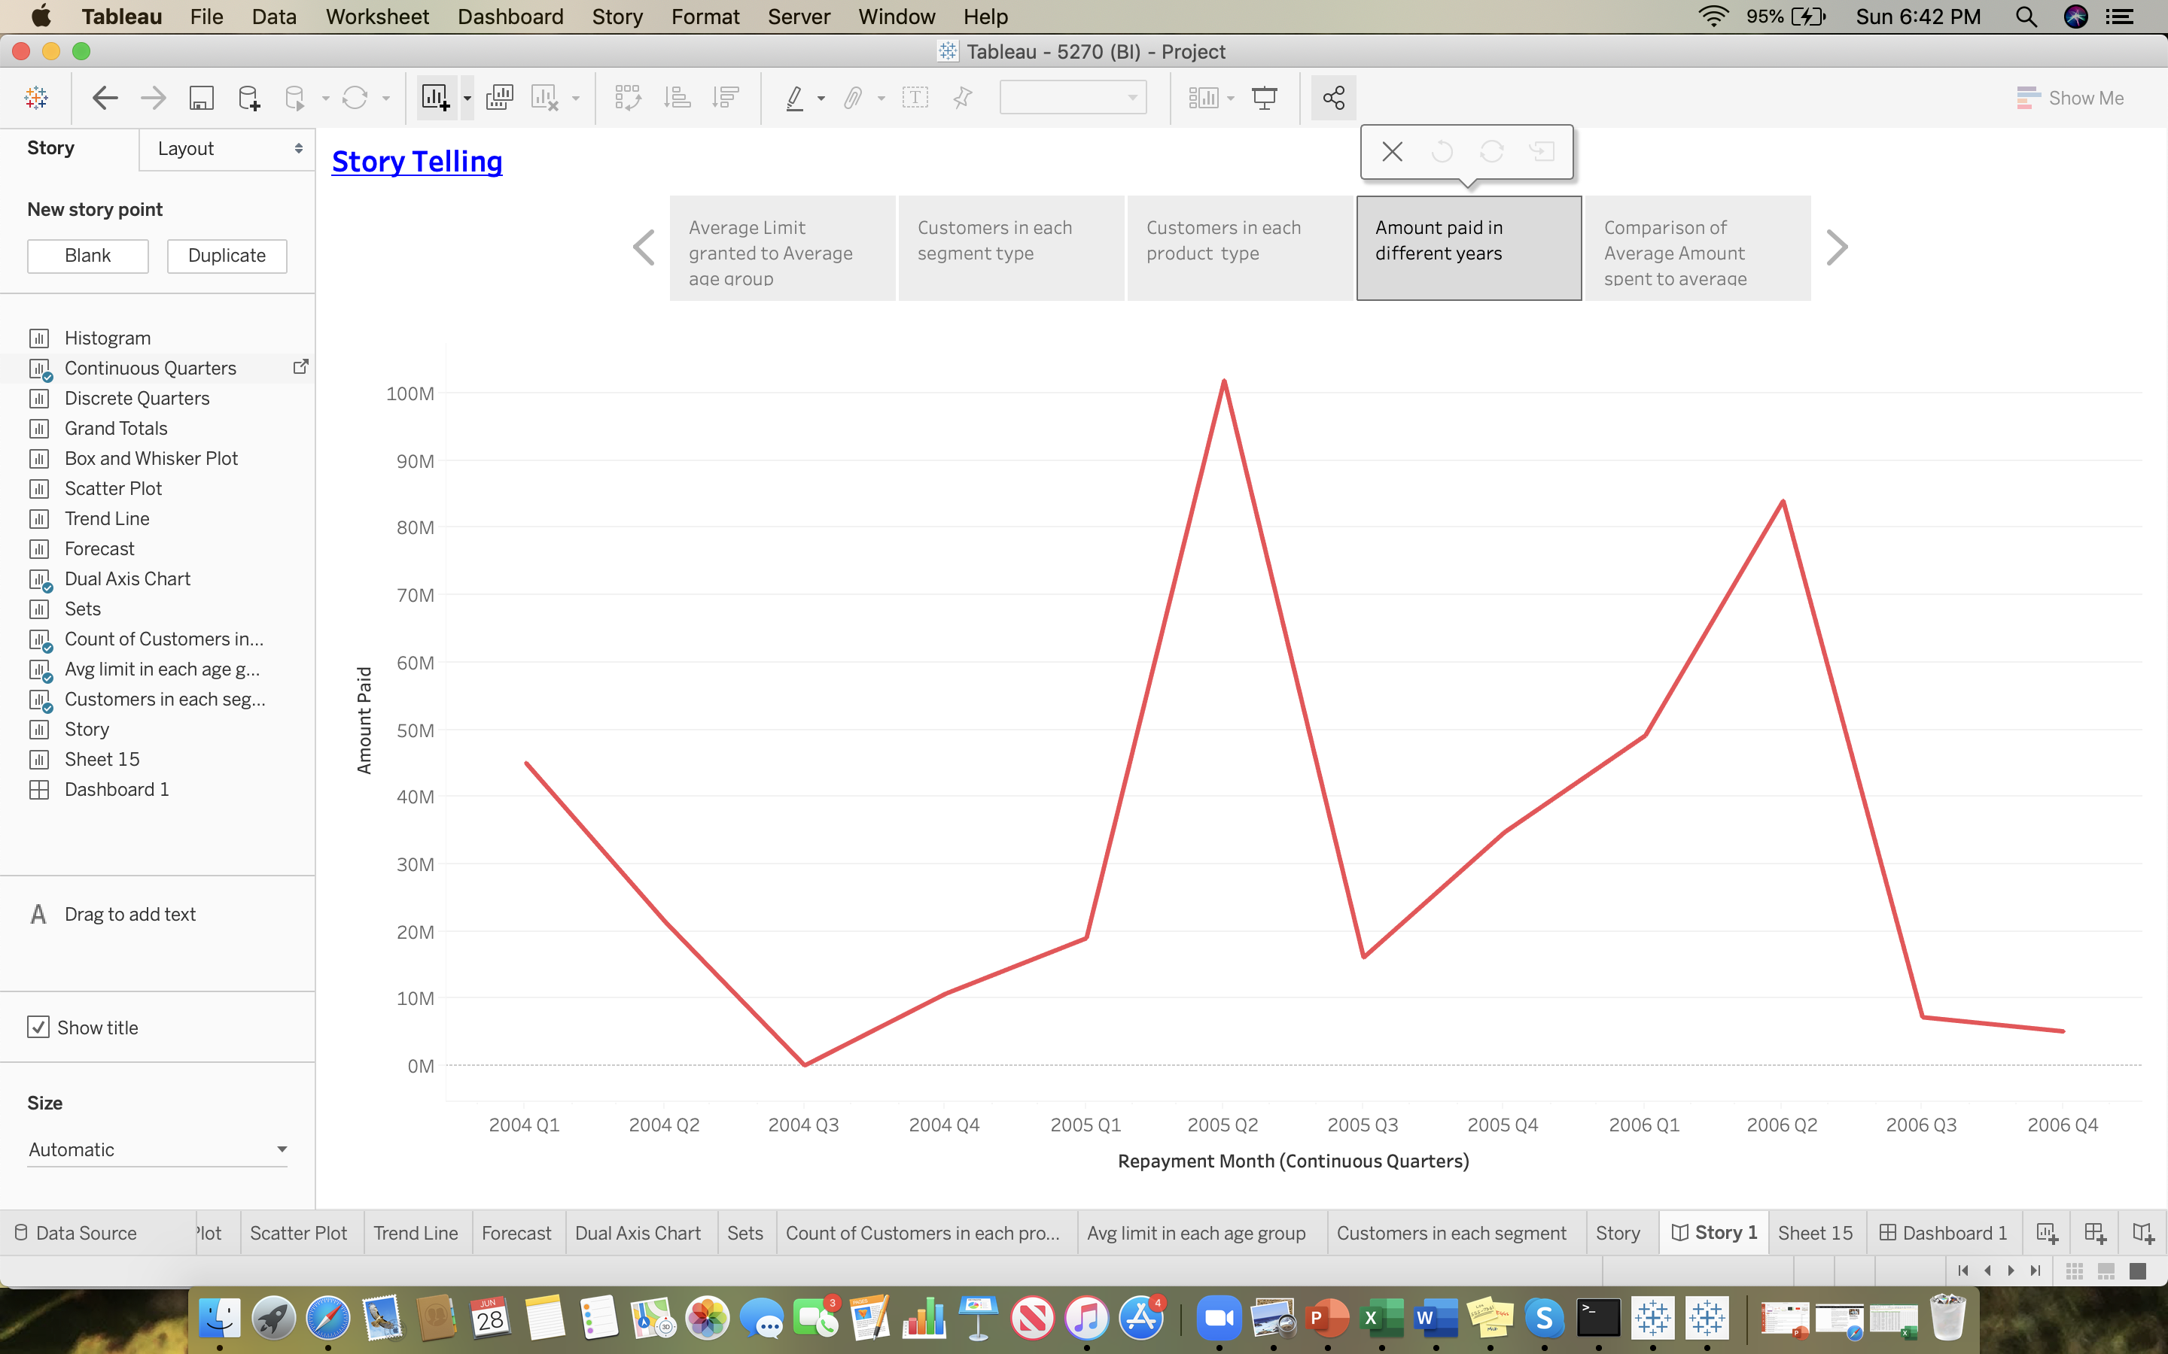

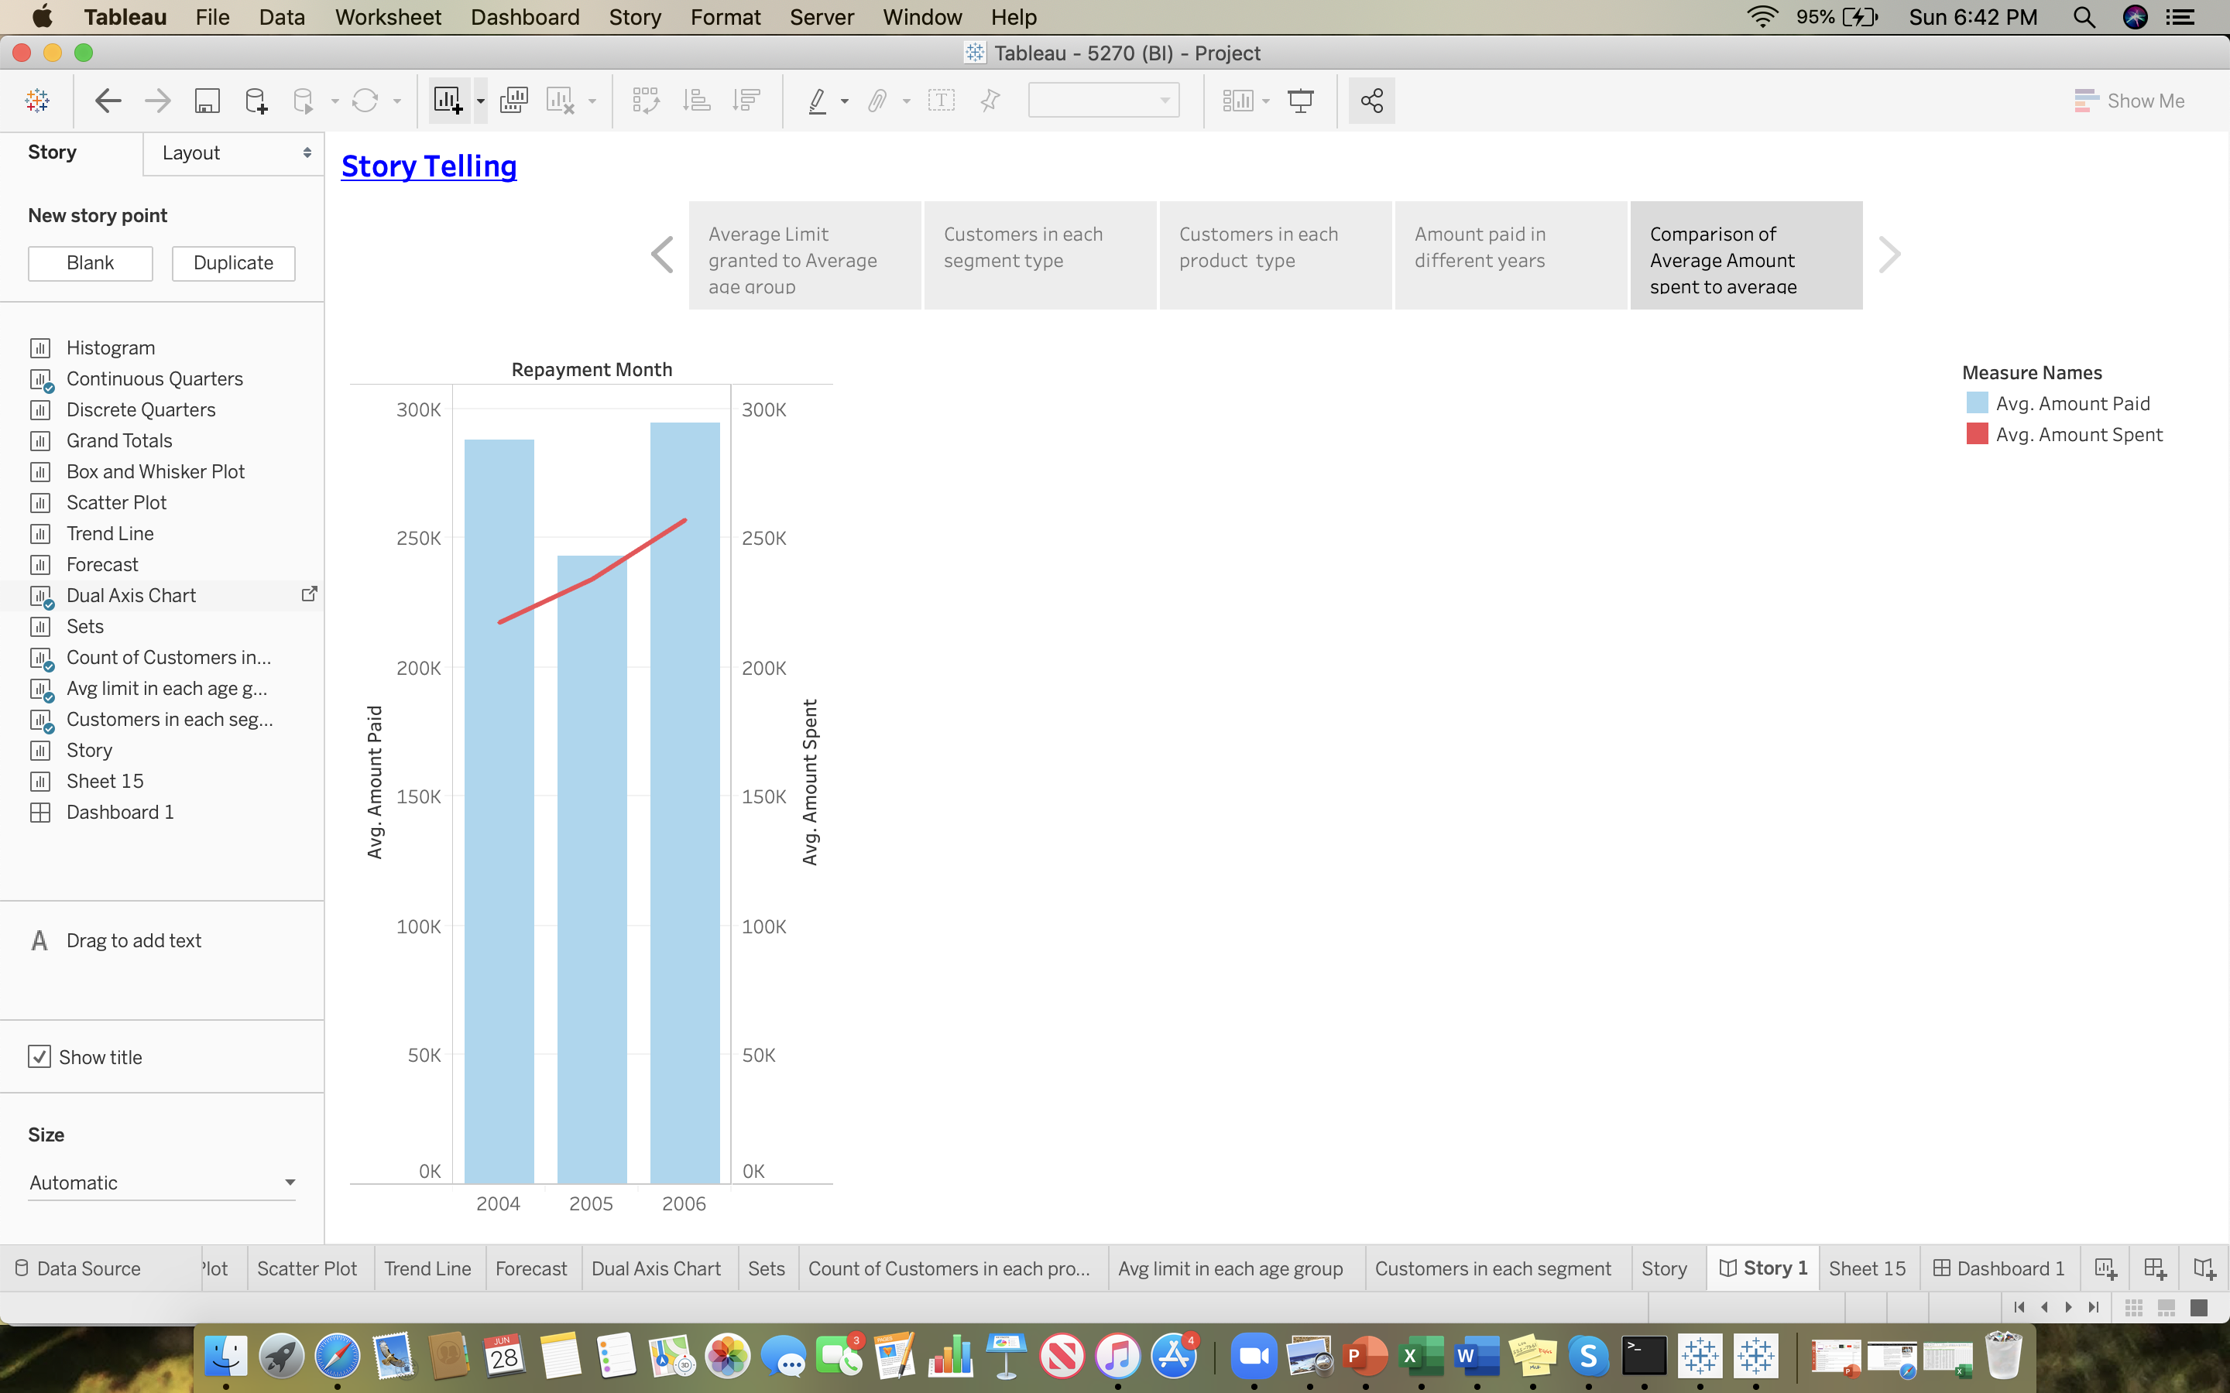

Story Telling is an important aspect of data visualizations on Tableau as it makes personal connection with data and it will show sequence of visualizations that work together to convey information as to narrate the story, how decisions relate to outcomes.

A story would be updated in sheet use to create, name and manage worksheets and dashboards apply to stories and it consists of collection of sheets arranged in a sequence. Each individual sheet in a story is called story point.

Let us start with the first step in story telling When someone applies for a credit card they would collect the documents to ascertain the financial position of a customer to see whether they would be able to pay the amount used. Based on the social status and the income of any individual income credit card company grants the card and gives a limit to every individual card holder to spend based on the age factor as well. There are different variety of customers apply for a credit card who work in different sector like Govt, Private, MNC, or do a business

While granting credit to these professionals they will check what’s the income on a monthly basis, yearly basis whether the income is standard or fluctuating these all factors are considered. we see in the second visualization how many customers are there for each segment type and we can also assume the more customers to one segment also signifies that they are safest people to lend because every business would need creditability, accountability and responsible to pay off their credit card debit. Now we would be doing deep dive analysis with the third story point to find the number of customers for each product type .Here for every credit card company there are 3 to 4 different product types exist so based on customer income and their credit score credit card companies would give different product types to different individuals for this company there are three product types Silver, gold and platinum. When we are talking about credit rating of the customers these ratings are given by the third parties to individual based on the number of loans, number of times customer has defaulted, how many times customer has repaid his debt lately by how many days. In-order to grant a credit card their credit score should be higher than 750 for assigning Gold credit card and more than 800 for platinum credit type. The silver card type would be giving less credit limit and has limited features, Gold card type customer would be having more privilege than more benefits like cashback, discounts, memberships etc.

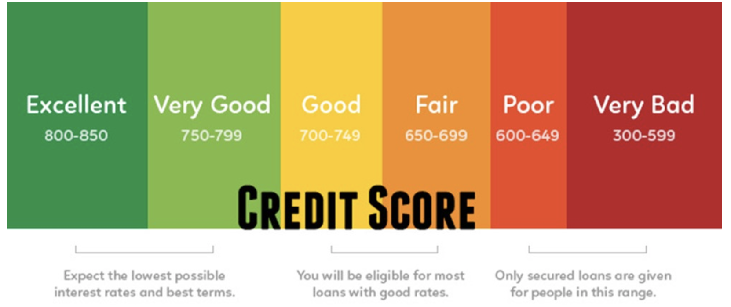

I have divided the product type in three product type silver, gold and platinum and used bin for the age type and count function to figure out the number of customers for each age group. The age group who holds the credit card starts from the age 20 and it goes on to the age of 75 let us start with the Gold type card for the age group 20 there are 59 customers that is the youngest age a person can hold the credit card. The highest number of customers is for the age group of 25 and there are 181 customers and the lowest number of customers is 1 in the age group of 30 and 55. For the platinum card type the highest number of customers is 95 for the age group of 35 and lowest number of customers is 18 for the age group of 20 and 65. Let us look at the basic card type which is silver the highest number of customers is for the age group of 50 has 56 customers and the lowest being in the age group of 55 with only 1 customer. Now we move to the next story point Amount paid in different years this is important for every credit card company to analyze how much amount of money is recovered from their customers because they need to balance between the spent amount and the amount paid amount as there would be liquidity of the company can be known. As the credit card company provides credit to lot of customers but its important for every company to get that amount back as they have to repay to their investors, pay salary to their employees and pay amount to their vendors if they can’t pay on time their business gets disrupted. They can take decisions on collection teams to call, email customers to repay money so let’s see the amount paid by the customers for all the three years we have used repayment month and amount paid and used continuous series to see the repayment in each quarter. In 2004 the first quarter collected the highest amount of money of Rs 45,050,793 and the lowest amount collected in quarter 3 of 2004 that is Rs 31,836. When we move to the next year 2005 the highest amount of money collected in quarter 2 of the year with Rs 101,986,577 and the lowest amount collected for quarter 3 is Rs 16,092,371.

Let’s see for the last year 2006 the amount collected in quarter 2 has been the highest among all the quarters with Rs 84,049,944 and the lowest performance was in the last quarter of 2006 with Rs 5,101,272. We will compare all three years on an average the best performance of collected the amount was in the second quarter on an average and the worst performance is done in quarter 3 It is the lowest among all the three. The management team has to analyze and make sure why in the quarter 3 of every is performing less and needs to improve collections by introducing new offers who ever pay before the deadline there will be exciting offers, or probably offer them cash back on few purchases which would attract the customers to pay on time and also the size of collection team should increase so that they can follow up regularly to pay the money on time.

We will move on to the last story point which is comparison of Avg amount paid to Avg amount spent in this visualization. This is helpful in reconciling between incoming and outgoing money as the customers are assigned some limit and the customers would spend certain amount of money on various products and services. We have used three attributes like repayment year, Average amount paid, Average amount spent and we have also used filter for food as this analysis is useful for every company to see what ever the money spent by the customers are they paying it correctly or not this may be previous year balances in Amount paid however they should be less difference between the amount paid and amount spent for liquidity of company. The visualization is prepared for three 3 years 2004,2005 and 2006 and also used Dual Axis method to plot the attributes Average amount paid on the left side and Average amount spent on the right side and also used the bar chart for Average amount paid and line chart for Amount spent to identify the point of difference for each year.

First we will take a look at the year 2004 Avg amount spent is Rs 217,436 and the average amount paid is 288,085 and see the difference is Rs 70649 and we move to the next year Avg amount spent Rs 234,233 compare to the average Amount paid Rs 242928 and let’s see the difference in figures is Rs 8,695 this is absolutely amazing whatever the credit used by the customers they also paid back this seems to be nice recovery rate and now will observe the last years figures Average amount spent is Rs 257,134 and the average amount paid is 294,757 and the difference is Rs 37,623 and the best among the recovery difference is the year 2005 and the lowest is 2004.

**References:**

1. BarbaraMarquand.5easywaystotrackcreditcardspending.Retrievedfrom  <https://www.forbes.com/sites/moneybuilder/2011/06/10/5-easy-ways-to-track-credit-card-spending/#7afd453b468c>
2. MELISSA LAMBARENA.Why you need a separate credit card for work expenses. Retrieved from  <https://www.nerdwallet.com/blog/credit-cards/making-purchases-for-work-get-separate-credit-card/>
3. ANDREW BLOOMENTHAL.Investopedia- credit card. Retrieved from <https://www.investopedia.com/terms/c/creditcard.asp>
4. Eva Murray.How do you tell A story with data visualization? Retrieved from <https://www.forbes.com/sites/evamurray/2019/02/06/how-do-you-tell-a-story-with-data-visualization/#2b6fae554b58>
5. LATOYA IRBY.Credit card payment allocation explained. Retrieved from <https://www.thebalance.com/credit-card-payment-allocation-explained-960084>